Recap:

Overall

* Our group selected the Raspberry Pi as the control system or control computer

The RasPC

* Our group assembled a development demo to show
  + Portability – Size/space occupied by the Raspberry Pi-based control system
  + Versatility – Connectivity through USB ports, Bluetooth, and Ethernet
  + Custom accessories – Touchscreen
  + Power Management – Wired through micro-USB charger or wireless through a battery and micro-USB charger
* Our group demo these capabilities during a Skype meeting with NBME in December 2015

Update:

Overall

* Our group focused on furthering the capabilities of the Raspberry Pi-powered control system by:
  + Ensuring connectivity and compatibility with Arduino board and the Arduino IDE
    - The Raspberry Pi, through the Raspbian OS, can run the Arduino IDE and communicate to any Arduino-compatible board through serial communication
    - Serial communication was achieved through the on-board USB ports and wirelessly through Bluetooth
      * Up to three (3) antennas has been connected, simultaneously, over Bluetooth
  + Developing a graphical user interface (GUI) that controls the communication and data acquisition from the wirelessly connected Arduinos (Figure 1)
    - Our group used Processing to develop the GUI (Figure 1)
    - The GUI takes advantage of the touchscreen to for users to interface directly with the control program (Figure 1)
    - The GUI was program to execute on startup of the system, reducing user interaction with the Raspbian OS and thus eliminating potential error
    - The Processing GUI communicates and controls the connected Arduinos directly, reducing the number of independent scripts or functions that must be executed by the Raspberry Pi
    - The communication with Arduino boards requires that the Firmata library is installed in the Arduino board
    - The Firmata library is actively supported and recommended by the Arduino and Processing communities
    - Through the Firmata library, the Arduino can communicate with processing as fast as 57600 bps
    - One Arduino board has been dedicated to each device
    - The Otoscope prototype, controlled by an Arduino Pro Mini, was demoed to NBME in late February

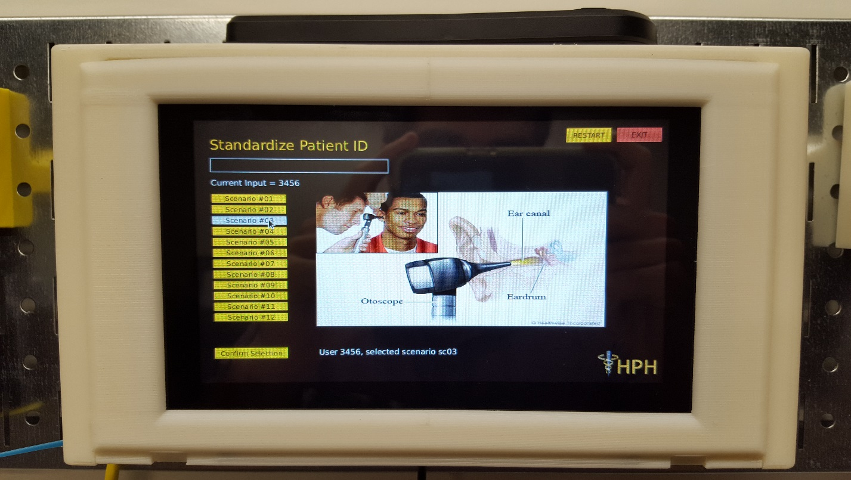

Moving Forth:

* Our team will acquire the Raspberry Pi 3, which features a 50% faster processor and embedded Bluetooth and WiFi antennas
  + All software will be compatible, including the OS and the Processing GUI
  + Embedded antennas will release physical ports that otherwise would be taken be adapter or dongles (eg. Usb Bluetooth or WiFi antenna)
* Our team will modify the GUI and the current connection protocols on the basis of the feedback obtained at the late February demo with NBME